TOWN OF NORWOOD

URBAN 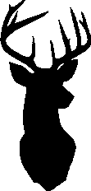 ARCHERY
SEASON
2023 GUIDELINES
The following is a slight adaption of the UAS rules for deer season that would allow for the use of archery equipment to
hunt deer within the town limits.

FAQ'S

WHEN CAN I HUNT?
January 14 - February 19

WHAT HUNTING WEAPONS CAN I USE?

The NC Wildlife Resources Commission limits deer hunting during the Urban Archery Season to "bow and arrow, or crossbow". No Firearms!

WHERE CAN I HUNT?
You must have written permission from the property owner if you are hunting on someone else's land (must be carried at all times), and the tract must be large enough (see below) to meet the requirements of the ordinance. This is known as an "area of consent".

CAN I HUNT ANYWHERE WITH PERMISSION?
No! A number of limitations are in effect to keep both hunters and city
residents safe. These are:

FAQ'S

CAN I HUNT ANYWHERE WITH PERMISSION?
- You must hunt from an elevated platform, at least ten (10) feet above the ground. A proper safety harness or fall restraint system is also necessary from this height.
- Hunting areas ("Areas of Consent") must be at least two (2) acres in size.
- Do not release an arrow if you are within 250feet of a house, school, church, business, government property or park.
- Do not release an arrow if you are 250 feet or less from the boundary of the area of consent.
- Do not release an arrow from or on to an electrical or water/sewer right­ of-way.

WHAT'S NEXT?
You now have the responsibility, both to fellow residents and as a conscientious hunter, to make every effort to track down the deer and complete the harvest. That means you find the deer, report the big game tag (required by NC Wildlife Resources}, and remove the deer carcass. You are not to field dress the deer and leave the rest of the carcass laying out to decay.

ADDITIONAL REGULATIONS:
There are a few, all of which are common sense guidelines:
- You need to make sure your hunting license is up to date. A valid hunting season must be in effect for which the hunting license applies.
- You need to make sure you are aware of and in compliance with all state hunting laws as well as local laws. These can be found at the NC Wildlife Resources Commission website (www.ncwildlife.org). Remember that a number of state wildlife laws apply in addition to the local regulations.
- You need to always be aware of your surroundings. Hunters are to exercise reasonable regard for the safety and property of others.

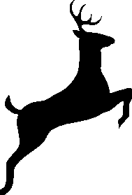
For more information about State hunting rules and regulations, please visit the NC Wildlife website at www.ncwildlife.org

