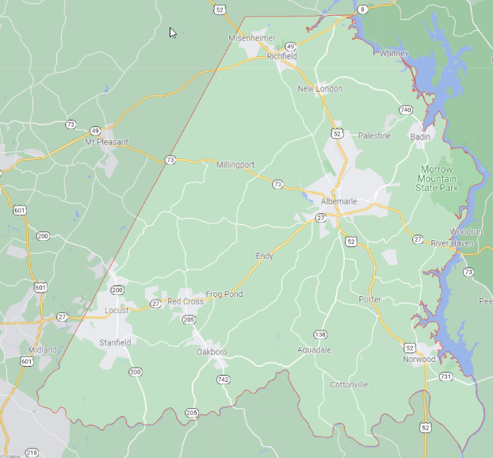
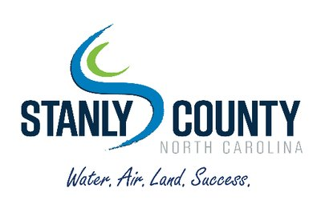
Stanly County is engaging in a coordinated and inclusive process to update its Comprehensive Land Use Plan. The Comprehensive Plan will capture the vision, values, and goals for Stanly County’s future.
Comprehensive Plans rely heavily on input from residents, property owners, and business owners to identify these goals and create strategies for achieving the County’s vision.
As you complete the survey – unless otherwise prompted – please think in terms of the County’s jurisdiction, not about the towns and cities within the County.

Please take 10 minutes to impact the future of Stanly County!
Your input will be incorporated into the County’s long-term plans, development codes, and/or annual budget as applicable.
How to Access the Survey
- Go to: https://www.surveymonkey.com/r/stanlycounty

- Use the QR code below.
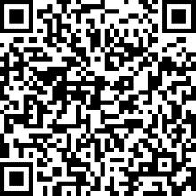

- Pick up a paper copy at Norwood Town Hall (212 S. Main Street, Norwood, NC 28128) and return it there upon completion.
The survey will be open until May 6, 2022.
Questions? Contact Bob Remsburg at bremsburg@stanlycountync.gov or Reaghan Murphy at rmurphy@centralina.org.

